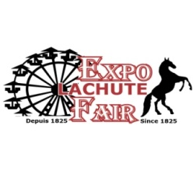

**FARM SAFETY TREASURE HUNT**

Follow the clues and answer the questions

Return this completed form and a chance to win a prize

At [info@expolachutefair.com](mailto:info@expolachutefair.com)

Clue #1- I am big and green, have 4 wheels and work on a farm. Visit Home page – Click on Tractor picture.

Go to station 1 - tractor safety

Question: What is the key word in red? _______________________________________________

Clue #2- I am a large animal that gives milk. Visit Home page – Click on Judgment

Go to station 2 – cattle safety

Question: What are the key words in red? ______________________________________________

Clue #3- I have 4 wheels and I work or play. Visit Home page – Click on Parade picture.

Go to Station 3 - ATV Display

Question: What is the key word in red? _________________________________________________

Clue #4- I am a very large animal used for work on a farm. Visit Home page – Click on Mini-farm picture.

Go to station 4 – Horse safety

Question: What is the key word in red? ________________________________________________

Clue #5- I am found on farms and I am used to clean and to control weeds. I am dangerous

Go to Station 5 – Chemical safety. Visit Home page – Click on Exhibitions picture.

Question: What are the key words in red? _______________________________________________  
  
**NAME___________________________________________AGE_______**